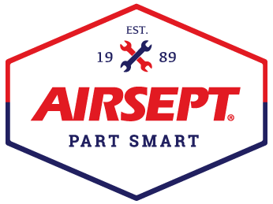

News Release

AirSept Introduces Automatic Dual Recycle Guard™
Automatically filters refrigerant and prevents unwelcome A/C machine downtime

Atlanta – June 29, 2023 – AirSept, recognized as the leader in developing solutions for complex automotive repair problems, now offers fully automated protection for most brands of A/C service equipment. The new Automatic Dual Recycle Guard™ (ADRG) safely and effectively captures sealant, debris, dye, excess lubricant, and other contaminants to protect expensive A/C recovery equipment without adjustment or monitoring. When it comes to capturing and replacing A/C refrigerant, many leak and seal type sealants can plug tubing, restrict valve movement, damage solenoids, and alter the seal’s shape and performance. AirSept’s Automatic Dual Recycle Guard filters out sealant and other contaminants from the refrigerant before it ever enters the refrigerant recovery machine.

Automatic Dual Recycle Guard incorporates a new activation technology that does not require an electrical interface with A/C service equipment. This feature ensures that ADRG is always in the correct operating mode. ADRG is designed with two internal filters to provide simultaneous high and low side protection. Automatic Dual Recycle Guard traps both stop-leak and seal sweller type sealant and works with all A/C recovery machines. Simply hook up Recycle Guard with either ½” ACME or ¼” Flare fittings and a 36” R134a hose. Easy to drain and available with replaceable ADRG filters in either a two or four pack, Automatic Dual Recycle Guard is easy to use and maintains continual refrigerant flow while in operation. AirSept also offers an ADRG Hose Assembly Kit that includes 72” high side and low side charging hoses with quick couplers and high and low side quick connect service adapters.

AirSept President, Aaron Becker, says, “Refrigerant recovery equipment is expensive, and time is money. Downtime can cost thousands in both equipment repair and lost service revenue. Automatic Dual Recycle Guard protects your investment and saves time as there is nothing to hook up per job. It is compatible with most automatic A/C service equipment and switches automatically from recover to recharge while maintaining a full refrigerant flow.”

For more information on AirSept’s Automatic Dual Recycle Guard, designed to protect the long-term function of expensive A/C refrigerant recovery machines, visit www.AirSept.com.

# # # #

Image Attached: 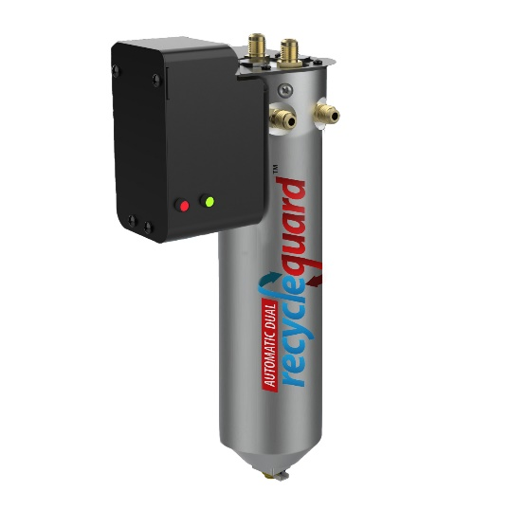
Caption: AirSept Automatic Dual Recycle Guard

About AirSept
In 1989 AirSept created the first long-lasting solution to the problem of unwanted mold and mildew odor in automobile air conditioning systems. The product quickly became popular and in 1991 AirSept was incorporated as a company. AirSept began partnering with global OEMs and suppliers to not only market its Cooling Coil Coating, but to also develop other unique, new problem-solving products. From those humble beginnings, AirSept has grown to be the industry leader in the development of OEM and aftermarket solutions to complex automotive repair problems. AirSept products are designed to save time, money, and labor. For more information, visit www.AirSept.com.

For further product information, contact:
Aaron Becker, President
AirSept
678-973-2287
abecker@airsept.com

Leslie Allen
Owner
Wildcat Communications
615-429-7965
leslieallen.wildcat@gmail.com

